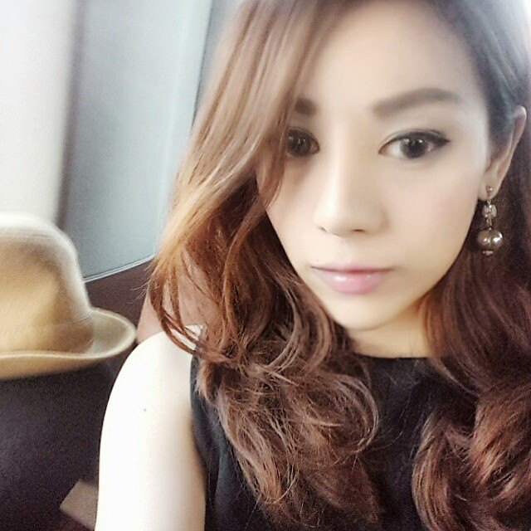**Karnpitcha Phongluangtham  *(Nelly)***

**Home:**  14/2 Sukhumvit 64

Soi Baan Suan Mahawong 1,

Phrakanong, Bangjak,

Bangkok 10260 Thailand

**Personal Profile:**

Date of Birth**:** 29th June, 1986

Place of Birth**:** Bangkok, Thailand

Nationality**:** Thai

**Contact Details**

**HP:** **(+66) 9 539 – 22 - 504**

**Email:** neoy.pumpkins127@gmail.com / neoyneui@gmail.com

**Skype:** neoy.pumpkins127

**Educations** : (Diploma & Degree)

* ***Bachelor of Arts (Hons) in Mass Communications,***

***Major in PR & Journalism (Class II Divison II)***

*Liverpool John Moores University, Liverpool, UK (2013 – 2014)*

* **Higher Diploma in Mass Communications,**

**Major in PR and Journalism (Credit)**

*Cambridge International Associate* partner

with *TMC Academy Singapore* (2010 – 2-11)

**Educations :** (Secondary & Primary Educations)

**Secondary Educations :**

**St. John’s International School** *(2002 – 1999)*

Accredited by International and Thai Ministry of EducationalMember

of CIS, BISW, FOBISSEA**.**

**IGCSE’s (O’Level)**

*Art & Design* (**A**), *First Language Thai* (**B**), *History* (**B**),

*English as a Second Language* (**B**), *Mathematics*(**C**),

*First Language English* (**C**), *Literature* (**C**)

**Primary Educations :**

**The Regent's School (ISR) – Thailand** *(1999 – 1997)*

Accredited by International and Thai Ministry of Educational

Member of CIS, CFBT, FOBISSEA

**TOEIC score: 885 IELTS: 6**

**Past working experiences: *range from oldest to most recent.***

**Sunbelt Asia (Legal Advisor)** (2006 - 2007)

***Paralegal/Customer Service***

* Give assistant to lawyers
* Co ordinate work between clients and lawyers.
* Taking care of my clients’ needs.
* Translate agreements/contacts/ Drafting letter.
* Schedule/Cancel appointments.
* Issue Retainers.

**Crystal Lounge Galleria (Crystal Boutique Store & Restaurant)** (2007)

***Secretary to Marketing Director***

* General secretarial duties.
* Assisting Marketing Director.
* Plan marketing plan – contact TV shows, Magazines etc.
* Dealing/Contacting/Corresponding with clients.
* Updating customer database.
* Make sale reports.
* Members follow up/Take care/provide service to the customer.
* Occasionally, in charge of the cashier

**Royal Siam Trust, Land Banking Company** (2007 – 2008)

***Assistant to General Manager***

* Assist the Manager with all admin works, filing documentary, input client’s database, updating client’s information/reservations, updating newsletter (concerning land values, new investments in Thailand etc.)
* Do monthly commission reports for the brokers, research on current land property prices, housing project etc.
* Finding contacts for new brokerage /financial advisory company create client’s payment schedule.
* Act as a coordinator with our oversea branch, and also perform any other tasks as assign to by the Managing Director.
* Act as a coordinator in collaborating works with oversea, arrange plane tickets, hotel reservations, do minute of meeting etc. and all other secretarial works.

##### 

##### 

##### 

##### [Monopolydesign Limited](http://www.linkedin.com/search?search=&company=Monopolydesign+Limited&sortCriteria=R&keepFacets=true&trk=prof-exp-company-name) (Creative Agency) (Feb’08 – Jan’09)

#### 

#### [Executive Assistant](http://www.linkedin.com/search?search=&title=Executuve+Assistant&sortCriteria=R&keepFacets=true&currentTitle=CP&trk=prof-exp-title)

* All secretarial tasks assigned by the MD
* Minute of Meeting
* Daily Memorandum
* Arrange meetings
* Arrange travel plan: flights, hotels, transportations,
* Keep track of office suppliers
* Acts as liaisons between Bangkok office and HK's office.
* Take care of MD's personal errands.
* Coordinate works from MD to Creative’s and AE’s.
* HR Duties include; keep track of employee's punctuality and attendance,  
   recruiting, scanning candidates, schedule interview.
* AE responsibilities: Do market research on client's product/their competitor’s etc. then Prepare PPT presentation to present to clients.
* Create creative brief and de-brief between clients and designers

##### [Fret Free Productions Co., Ltd.](http://www.linkedin.com/search?search=&company=Fret+Free+Productions+Co%2E%2C+Ltd%2E&sortCriteria=R&keepFacets=true&trk=prof-exp-company-name) (Internship)

##### *Project Executive*

* Management of all aspects of projects, ensuring that a high quality service is provided to each and every client.
* Supervise production suppliers and Management of all aspects of projects, ensuring that a high quality service is provided to each and every client.
* Supervise production suppliers and partners ensuring that every project is delivered on-time, and according to Fret Free Productions' quality standards.
* Negotiate costs and production details Management of all aspects of projects, ensuring that a high quality service is provided to each and every client.
* Supervise production suppliers and partners ensuring that every project is delivered on-time, and according to Fret Free Productions' quality standards.
* Negotiate costs and production details with suppliers.
* Develop project proposals for clients.
* Implement Fret Free Standard Operating Procedures for all projects.

**WoodyWorld Co., Ltd**

**Personal Assistant to Mr. Woody Milintachinda**

* All secretarial tasks assigned by MD, includes; booking trips (Hotels/plan tickets/Transportations/Restaurants etc) Deals a lot with overseas hospitality.
* Plan the entire overseas trip
* Minute of Meeting
* Taking care of both business and personal matter of MD
* Prepared banquets/flowers/gifts to important people
* Assigned to help PR manager; taking care of Artist's demanding list/updating on artist's schedules/prepare PR kit to send to media outlet
* Buying add on youtube
* Helped organized music festival S2O's (4days) music party during Songkrang days
* Recruiting models for commercial shoot
* Writing spot/commercial scripts
* Had experience selling tickets along with looking after celebrities' guest list
* Experiences in on location shooting, making sure the set goes on smoothly